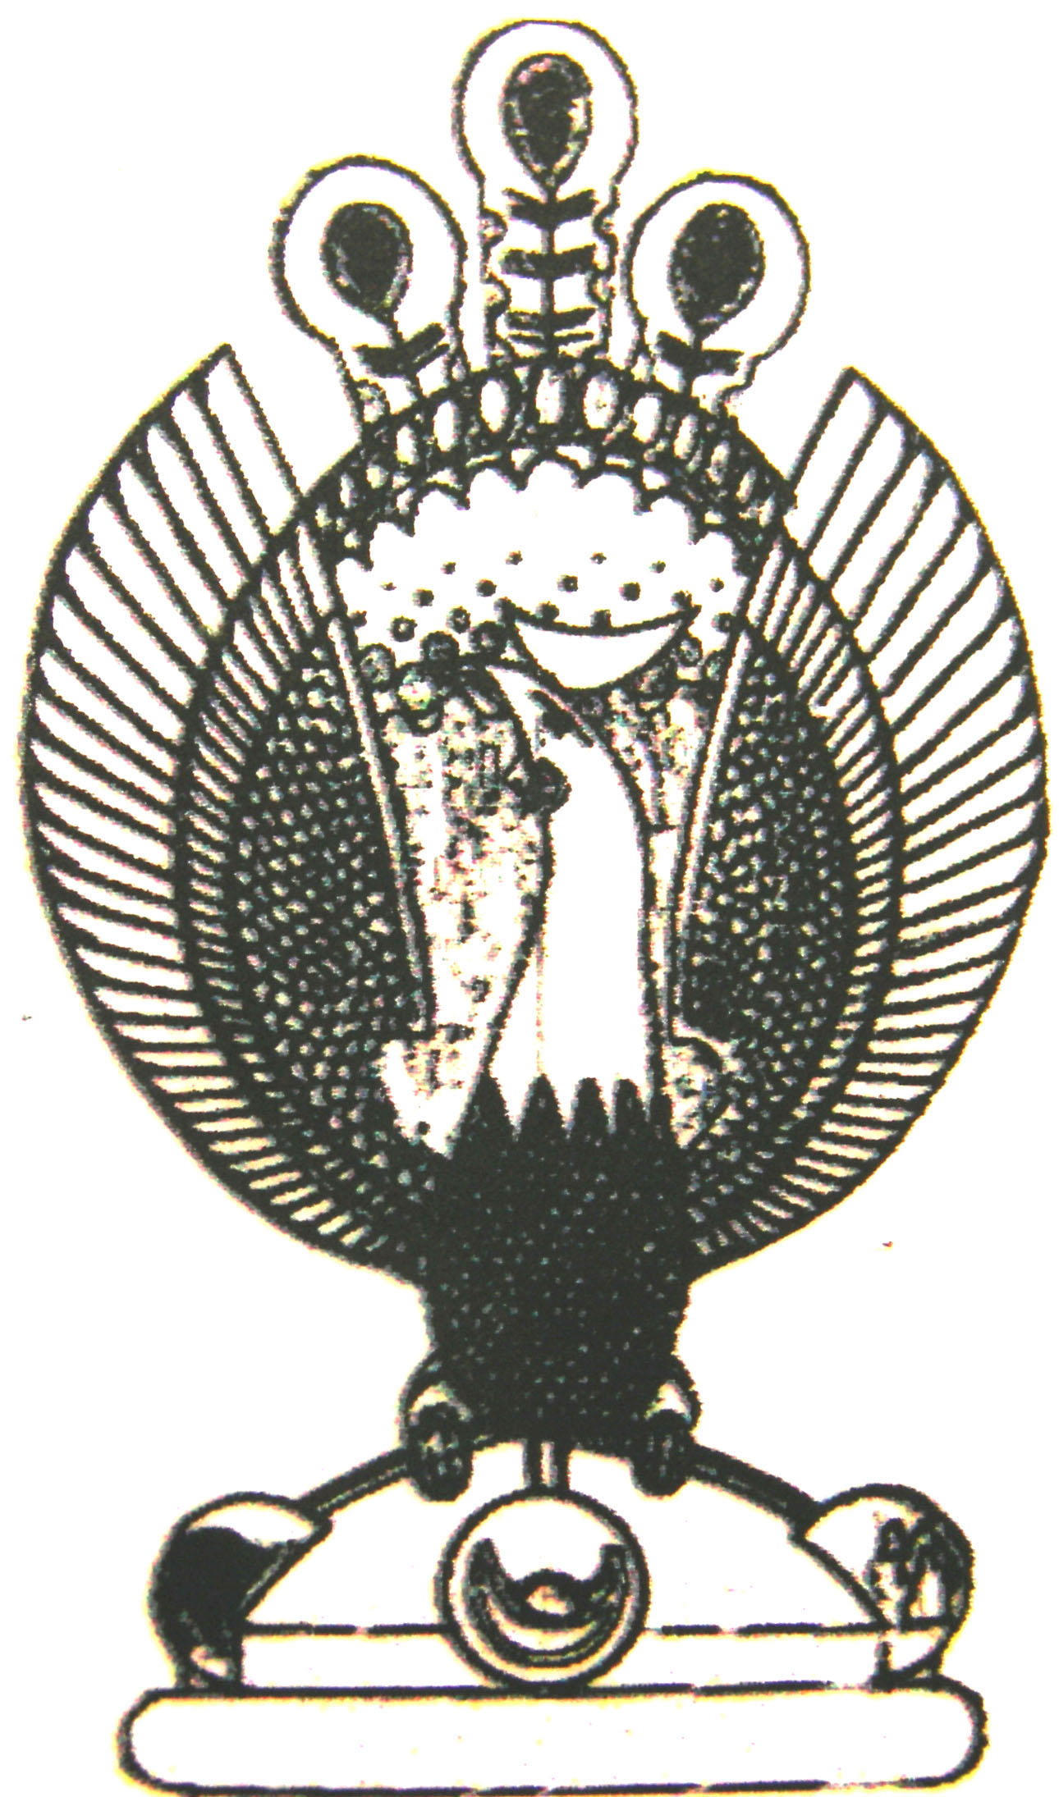

THE HERITAGE

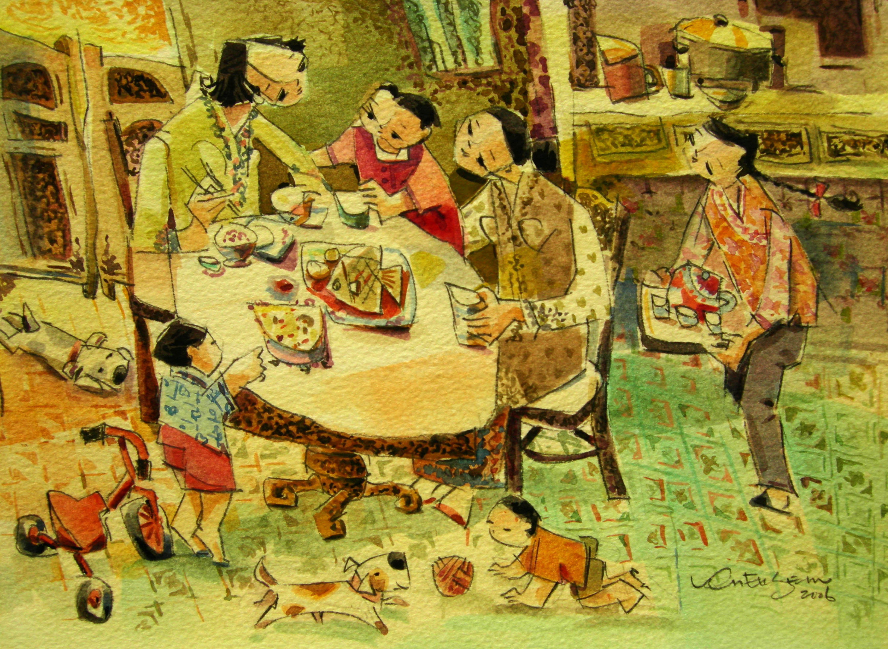
Tea time
Snacks and appetizers are an imaginative palette of colours, shapes and flavours.

